|  |  |
| --- | --- |
|  | **BAHRIA UNIVERSITY**  **(Karachi Campus)**  *Department of Software Engineering*  **ASSIGNMENT#01 – Fall 2024** |

|  |  |  |  |
| --- | --- | --- | --- |
| COURSE TITLE: | **Information Security** | COURSE | CODE: **CSC-407** |
| Class: | **BSE – 7A&7B** | Shift: | **Morning** |
| Course Instructor: | **Dr. Osama Rehman** | Date: | **15-Oct.-2024** |
| Due Date: | **21-Oct.-2024** | Marks: | **5.0 Marks** |
| **Instructions:** |  |  |  |

1. **Attempt all questions.**
2. **This is an individual effort task.**
3. **Only handwritten answers are accepted.**
4. **Write your full name, registration number and section on the title page.**
5. **Question#1 is a “Complex Engineering Problem (CEP)” having an attributed of no obvious solution.**
6. **Question#3 is a “Complex Engineering Problem (CEP)” having an attributed of no obvious solution & conflicting issues”.**

Q1. Taking the “McCumber Cube” into consideration, choose any one area out of the 27 possible areas to secure. Analyze and discuss how this area can be implemented to strengthen the security poster of Bahria University Karachi Campus.

**[CLO#4, CEP, 1.0 marks]**

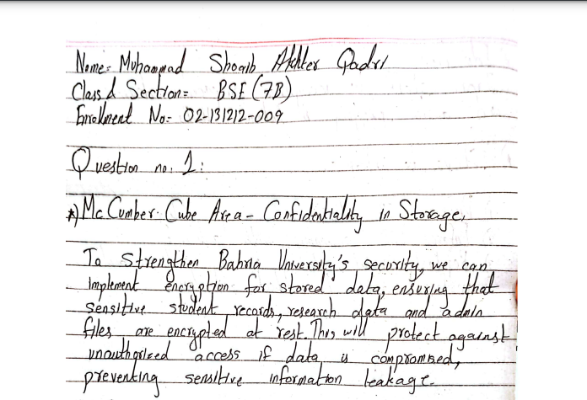

Q2. Install an Antivirus of your own choice over your personal smartphone device and perform a “Full / Deep / Root” scan on it. Afterwards, do the following: **[CLO#3, 2.0 marks]**

* 1. Mention the name of the Antivirus of your choice along with providing justifications regarding the choice. Provide one snapshot of the installed antivirus.

**Solution:**

The antivirus chosen for installation is **Bitdefender**. Justification for selecting Bitdefender includes its comprehensive protection features, user-friendly interface, high detection rates, and additional functionalities such as web protection, autopilot recommendations, and scam alert detection. Bitdefender is well-known for minimal system impact while providing robust security, which makes it an excellent choice for a smartphone antivirus solution.

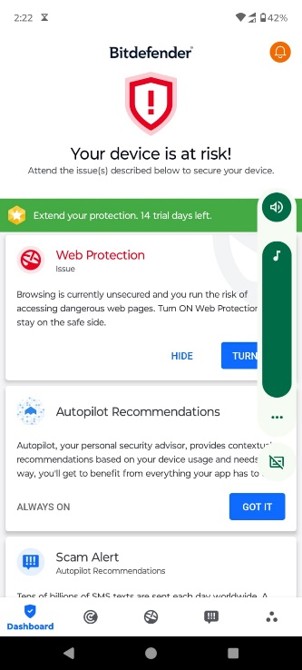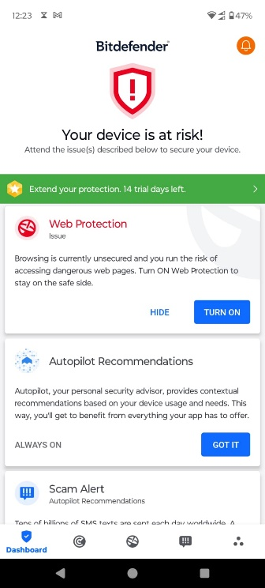

* 1. In case one or more malwares have been detected in the scanning processing, list those malware types / names. In case no malware has been detected, mention that no malware has been detected and put a snapshot of the virus scanning result.

**Solution:**

Yes, Web Protection malware has been detected. Here is the proof:

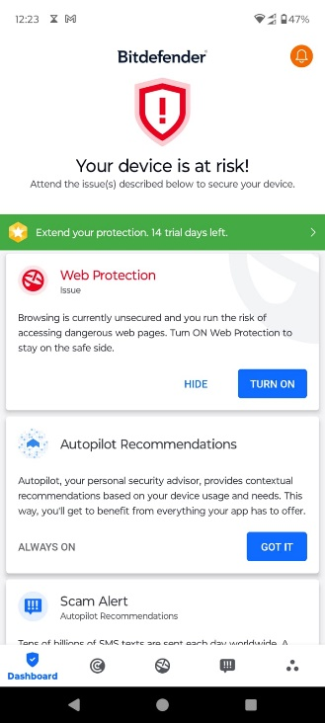

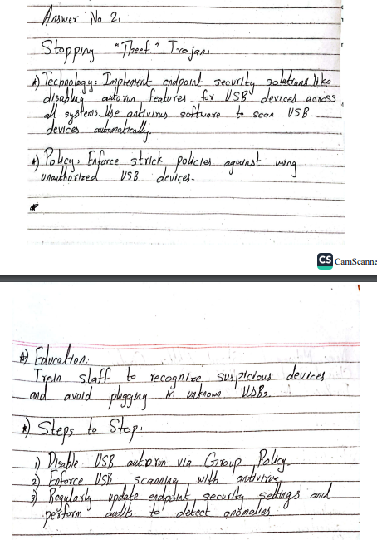Q3. “Theef” is a Remote Access Trojan (RAT) which can give an attacker a backdoor and remote access to a compromised computer. The attacker has hidden the .exe file of “Theef” into his/her USB and written a script in “autorun.inf” that would run this tool in the background automatically once the USB is inserted into any system, hence infecting the system. As a Security Analyst, explain how you can stop such attackers from affecting the systems in your work place through (Technology, Policy and Education). While discussing Technological solution(s), explain in details / steps-wise how would you stop such an activity.